Comparative Analysis of LSTM and a Traditional Machine Learning Model for Short-Term Energy Consumption Forecasting in Smart Buildings
Giovanni August Immanuel Wijaya
Computer Science Department
School of Computer Science
Bina Nusantara University
Jakarta, Indonesia, 11480
giovanni.wijaya001@binus.ac.id
Diana
Computer Science Department
School of Computer Science
Bina Nusantara University
Jakarta, Indonesia, 11480
diana@binus.edu
Karel Nathanael Tanoe
Computer Science Department
School of Computer Science
Bina Nusantara University
Jakarta, Indonesia, 11480
karel.tanoe@binus.ac.id
Shania Priccilia
Computer Science Department
School of Computer Science
Bina Nusantara University
Jakarta, Indonesia, 11480
shania.priccilia@binus.ac.id

Abstract—This study presents a controlled comparative analysis between a Long Short-Term Memory network (LSTM) and an Extreme Gradient Boosting (XGBoost) model for short term energy consumption forecasting in smart buildings. There is a noticeable absence of systematic benchmarking between pure deep learning and traditional machine learning algorithms under consistent settings, despite current trends that propose complex hybrid architectures. Both models were tested using a public dataset from a building in Bangkok, using the same preprocessing, feature engineering, and evaluation metrics. The performance was assessed using a final test partition and three fold time-series cross-validation. The results show that the XGBoost model surpasses the LSTM throughout all metrics, achieving RMSE of 21.35 kW and R2 of 0.9818 versus 28.21 kW and 0.9681 for the LSTM model, a difference confirmed as statistically significant by a Diebold-Mariano test (DM = 10.49, p < 0.001). Cross-validation shows that the LSTM model also displayed high variance when exposed to limited training data. This variance was especially found in early folds where training data was limited, revealing the data dependency in deep learning approaches. These findings suggest that traditional machine learning models can outperform complex deep learning models in training efficiency, requiring roughly 26 times less training time, and predictive capability, specifically when lag and rolling features are explicitly engineered.
Keywords—energy forecasting, smart buildings, deep learning, machine learning, comparative analysis

Introduction
Many modern buildings today have energy management systems that produce time-series data, which can be used to improve the energy efficiency and daily preparation of the building. Accurate short-term forecasts of consumption enable more cost-effective and demand-responsive energy use, better cost reductions and peak load management, and more sustainable long-term energy use planning. Forecasting in smart buildings remains challenging because system dynamics vary by building, consumption depends on environmental factors, and occupant behavior is highly unpredictable.
LSTM networks in particular have been found to provide better prediction of sequential building energy data than traditional models [1], [2]. Later work has incorporated attention mechanisms to gain interpretability [3], signal decomposition for noise reduction[4], [5], hybrid ensembles with SVR, Random Forest, BIM databases, or swarm intelligence [6], [7], [8], as well as transfer learning [9], neural architecture fusion [10], reinforcement learning [2], and other hybrid deep learning models [11]. Hybrid deep learning models have also been proven successful in short-term residential predictions [12], [13]. In all these comparisons, there is no single model that performs best in all building types and time horizons [14], [15].
Classical algorithms like kNN, SVM, and ARIMA are still widely used because of their lower training cost [16], [17]. Gradient-boosted tree ensembles like XGBoost are popular in tabular regression tasks such as building energy prediction [18]. The comparison between deep learning and these traditional families is still inconclusive, and the trade-offs vary based on the dataset and prediction horizon [16], [17].
Although many studies have explored load forecasting using statistical, machine learning, and deep learning approaches [19], a significant methodological gap remains regarding feature engineering and evaluation consistency. Tree-based machine learning models require time-series data to be transformed into tabular representations using lag and rolling-window features to capture temporal dependencies. However, previous building energy studies employing tree-based models have primarily relied on simultaneous environmental measurements rather than historical lag features derived from the target building's own energy consumption [18]. Therefore, temporal dependencies are often left out from the feature set of traditional machine learning models. Furthermore, comparisons between deep sequential models and traditional machine learning pipelines often lack methodological consistency [19], as different feature sets, data splits, or feature engineering procedures are often used within the same study.
To resolve this methodological gap, this study compares deep learning with traditional machine learning for short-term energy consumption forecasting in smart buildings using the same approach. LSTM was selected as the representative deep learning model because it serves as the foundational sequence architecture in the majority of related literature. XGBoost was chosen to represent traditional machine learning models because it outperformed LightGBM and other gradient-boosted variants in the benchmark reported in [18]. Other models were excluded to maintain a highly controlled experimental design. Random Forest and SVR have already been extensively compared in previous studies [16], [17], while Transformer-based models are more commonly evaluated using larger and more diverse datasets [14], [15], [18]. By utilizing the same pre-processed data, lag intervals, rolling feature engineering, train/validation splits, and evaluation metrics for both models, this research provides a rigorous assessment of their prediction accuracy, robustness, and computational efficiency to determine whether the observed performance differences are statistically significant under a strictly controlled experimental setting.

Related Work
As they are able to model temporal dependency of time-series data, LSTM models have been studied extensively to build energy forecasting for buildings. LSTM has been applied to predict the energy use of campus buildings, achieving good performance compared with other baseline models such as GPR and SVR, particularly in forecasting daily energy usage patterns [1]. A combination of LSTM and reinforcement learning has been proposed to predict building electricity consumption, increasing prediction accuracy by fine-tuning the hyperparameters on the fly [2]. Deep learning has also shown good results for predicting residential electricity usage at the initial stage [20].
Other studies adjust the LSTM model to address interpretability and noise sensitivity. An explainable LSTM with an attention mechanism has been proposed to detect the temporal features that contribute to each prediction [3]. The EEMD-LSTM model has been suggested to predict industrial energy loads in Vietnam by decomposing non-stationary energy loads for prediction [4]. An LSTM-based Kalman filters and wavelet transforms approach has been proposed to render robustness in building energy data [5].
The majority of current works are based on new hybrid architectures instead of conducting controlled experiments comparing traditional machine learning with pure deep learning [6], [7], [8], [9], [10], [11]. A review of load forecasting techniques suggested that the evaluation methods should be uniform across model families [19]. Few studies, however, conduct systematic comparisons with the same preprocessing and evaluation metrics. To this end, this study compares the LSTM model to conventional machine learning models, like XGBoost, for short-term energy consumption forecasting in smart buildings directly.

Methodology
This section outlines the comparative framework established to evaluate the predictive capabilities of a deep sequence architecture against a traditional tree-based ensemble model for short-term building-level energy forecasting using the CU-BEMS dataset. Fig. 1 illustrates the overall experimental workflow used in this study.
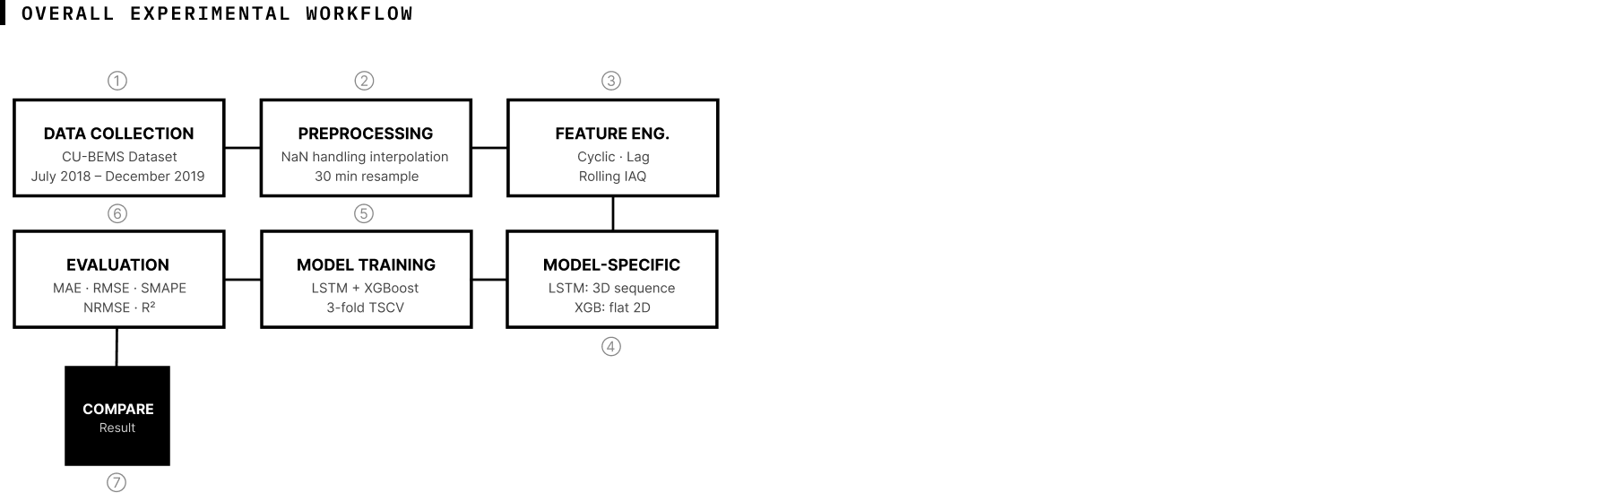

Data Collection
This study uses the CU-BEMS dataset, a publicly available benchmark collected from a 7 floor academic office building located at Bangkok, Thailand [21]. The dataset spans from July 1, 2018 to December 31, 2019, covering a period of 18 months and seven floors. Raw sensor readings are recorded at a one-minute sampling interval, making a total of 14 floor-year CSV files across two calendar years
Each floor file contains zone-level measurements for active power consumption (kW) across air conditioning units, lighting circuits, and electrical plug loads, as well as indoor environmental quality (IAQ) sensor readings of temperature (degC), relative humidity (RH%), and illuminance (lux) per zone. The forecasting target is the building level total active power consumption (Total_kW), derived by summing all power readings across all available floors and resampling to a 30-minute interval. During the initial data loading each floor file was analyzed individually.

Preprocessing
The preprocessing pipeline highlights both data quality and feature representation challenges found in long running IoT sensor usage. Missing value is handled using a two stage strategy on every floor before any aggregation.
First, short sensor gaps of up to 60 consecutive minutes were fixed per column using time-aware linear interpolation to preserve gradual temporal shape. In the second stage, rows where more than 50% of the kW sensor columns remained missing after interpolation were flagged as unusable, and was marked as a missing value on a floor-level power sum. Using only online sensors on a large-scale outage would corrupt the training and understate the true building load. A floor-level indicator was derived from the remaining missing columns and accounted into the building-level aggregation step.
After per-floor preprocessing, all files were combined and grouped by timestamp. The building-level Total_kW was computed as the sum of all floor-level active power, while IAQ features were computed as a building-wide mean across floors. The combined dataset was resampled to a 30-minute interval, making 26,352 samples. Before applying forward and backward fill to any remaining missing values, a binary quality indicator column was collected by marking all 30-minute intervals where any IAQ variable was missing before filling. Sub-load features (e.g., individual AC units, lighting, and plug-load measurements) were intentionally excluded from the final feature set. Although available in the dataset, these measurements are not always available across different smart buildings. This study is limited to the use of aggregate building energy consumption and basic environmental variables to assess the forecasting performance under conditions that are more representative of common building energy management systems. This design is intended to create a comparison of the two models under realistic operational constraints, and to ensure that the models are as generalizable as possible, while recognizing that the models may not achieve the highest possible prediction accuracy.
Feature engineering was then performed to encode temporal structure and environmental context. Four lag features (lag 1, Lag 2, Lag 48, and Lag 336) were created from the target, which represent loads prior to the target. Because the data is sampled in 30-minute intervals, Lag 1 represents the load 30 minutes before the target time, and Lag 336 captures the load from exactly one week prior. Rolling statistical features were calculated using the average and standard deviation of past loads over three time windows: 2 hours, 4 hours, and 24 hours. For IAQ variables, 1-step lag features and 2-hour rolling mean features were used. All rolling and lag features were applied in a 1-step shift prior to windowing to prevent any data leakage. Cyclic temporal encodings were constructed using sine and cosine transformations for hour of day, day of week and calendar month, adding six additional features. A flag to detect the weekend was included. Table I illustrates this feature derivation process for a single target prediction.
- Mapping of Historical Raw Data to Derived Features for a Single Target Prediction.
Relative Time | Total_kW | Used For (Feature Mapping)
T - 1 week | 96.4 | Lag 336
T - 1 day | 101.2 | Lag 48
T - 2 hour | 100.1 | Rolling window (2h)
T - 1.5 hour | 102.0 | Rolling window (2h)
T - 1 hour | 103.5 | Lag 2, Rolling window (2h)
T - 30 minute | 105.8 | Lag 1, Rolling window (2h)
Target (T) | 108.2 | Target variable to be predicted
Derived Output | Final Value | Calculation for target row T
Rolling Mean (2h) | 102.85 | Average of Total_kW from  T - 2 hour to T - 30 minute
Rolling Std (2h) | 2.41 | Std dev of Total_kW from  T - 2 hour to T - 30 minute
T represents the target time step being predicted.

Train model
This study compares two forecasting approaches: LSTM as the deep learning model and XGBoost as the traditional machine learning model. The dataset was divided into 70% training, 15% validation, and 15% testing sets without shuffling in order to preserve temporal order. This produced 18,115 training sequences, 3,806 validation sequences, and 3,807 testing sequences for both models.
The LSTM model was implemented in TensorFlow/Keras using three stacked LSTM layers with 128, 64, and 32 units respectively. Each LSTM layer is followed by a Batch Normalization layer and a Dropout layer with a rate of 0.2 to stabilize training and reduce overfitting. Two Dense layers with 32 and 16 units (ReLU) and a final single-neuron Dense layer produces the scalar output. The model was trained using the Adam optimizer with an initial learning rate of 0.001 and mean squared error as the loss function, with mean absolute error monitored as an additional metric. The model trained for up to 100 epochs with a batch size of 64, using Early Stopping (patience=15) and ReduceLROnPlateau (factor=0.5, patience=5, min lr=1e-5).
The XGBoost model was trained on the flattened sequence, in which each 96-step sequence of 24 features is represented as a flat vector of 2,304 input. The model was configured with 1,000 estimators, a learning rate of 0.05, a maximum tree depth of 6, a row subsampling ratio of 0.8, and a column subsampling ratio per tree of 0.8. The squared error objective was used, with RMSE as the evaluation metric and early stopping applied after 50 consecutive rounds of no improvement on the validation set.
To assess robustness beyond a single train/test split, both models were also evaluated using three-fold time-series cross-validation. In each fold, the MinMax scaler was fitted only on the training partition of that fold to prevent leakage. Fig. 2 illustrates the architecture of the LSTM model and Fig. 3 illustrates the architecture of the XGBoost model.
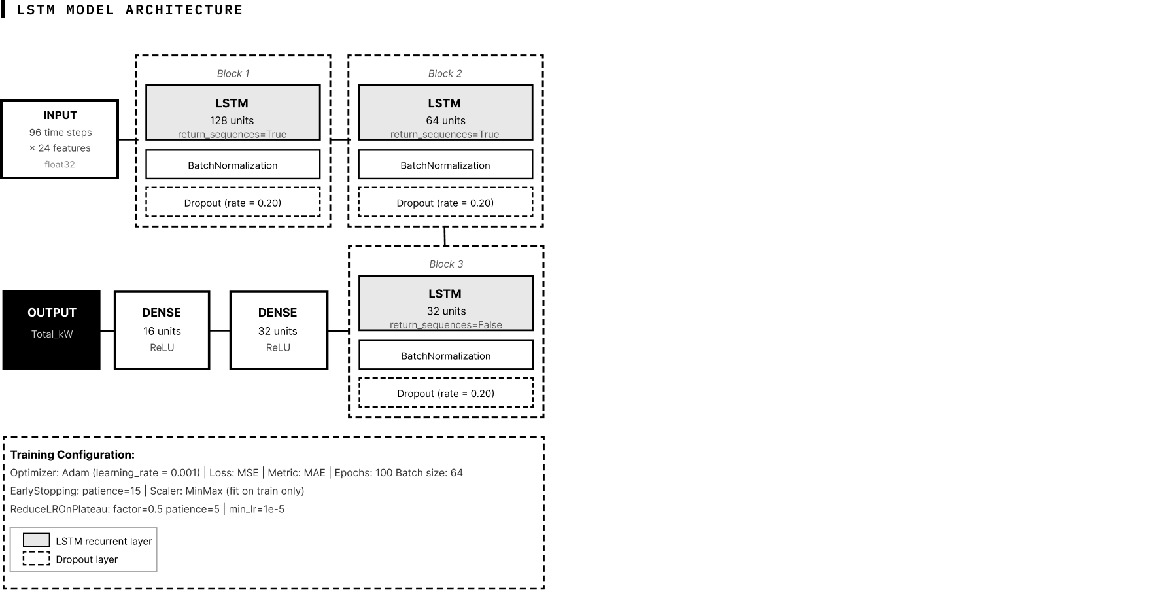
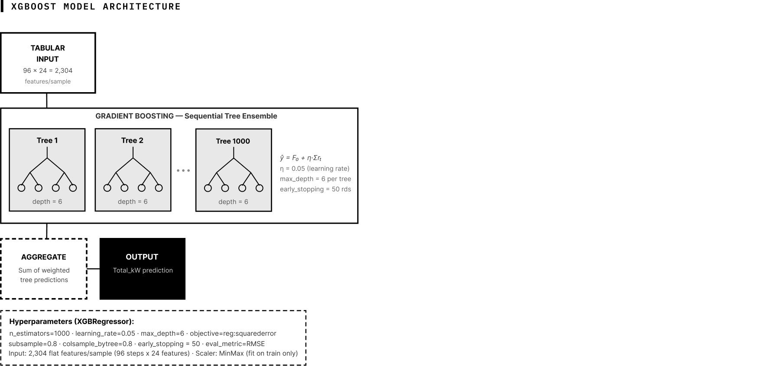

Evaluation
The forecasting models were evaluated as regression models, since the main objective of the study is to predict building energy consumption. Several standard regression metrics were used to assess predictive performance, such as:
Mean Absolute Error (MAE) measures the average absolute difference between actual and predicted values, as shown in (1).
$MAE =\frac{1}{n}\sum_{i=1}^{n}{\left|y_{i} - {\hat{y}}_{i}\right|}$ 
Root Mean Squared Error (RMSE) is the square root of MSE and expresses the error in the same unit as the target variable, as shown in (2).
$RMSE =\sqrt{\frac{1}{n}\sum_{i=1}^{n}{{\left(y_{i} - {\hat{y}}_{i}\right)}^{2}}}$ 
Symmetric Mean Absolute Percentage Error (SMAPE) measures the relative forecasting error by scaling the absolute difference against the average of the actual and predicted values, as shown in (3).
$SMAPE= \frac{200\%}{n}\sum_{i=1}^{n}{\frac{\left|y_{i} - {\hat{y}}_{i}\right|}{\left|y_{i}\right| + \left| {\hat{y}}_{i}\right|+ϵ}}$ 
Normalized Root Mean Squared Error (NRMSE) normalizes RMSE based on the range of the actual target values, as shown in (4).
$NRMSE = \frac{RMSE}{y_{max} - y_{min}}$ 
Coefficient of Determination (R2) measures how well the model explains the variance of the actual values, as shown in (5).
$R^{2} = 1- \frac{\sum_{i=1}^{n}{{\left(y_{i} - {\hat{y}}_{i}\right)}^{2}}}{\sum_{i=1}^{n}{{\left(y_{i} -\overline{y} \right)}^{2}}}$ 
These metrics provide complementary perspectives on model accuracy, including average error magnitude, scale-normalized performance, and goodness of fit. To confirm whether the observed differences in forecasting accuracy are statistically significant, a Diebold-Mariano test was applied to the paired test-set forecasts under both squared-error and absolute-error loss.

Result and Discussion
In this section, test results between models will be shown and analyzed. Before presenting model results, a naive persistence baseline was included in the final test set. It predicts the next 30-minute load by repeating the most recent value, formally expressed as t + 1= t. This baseline requires no training and the output is deterministic and invariant to the training window, therefore it was excluded from cross-validation. Results below are the final test set consisting of the last 15% of the dataset.
- Model Performance Comparison
Model | RMSE (kW) | MAE (kW) | R² | SMAPE (%) | NRMSE
LSTM | 28.21 | 17.93 | 0.9681 | 10.51 | 0.0395
XGBoost | 21.35 | 12.66 | 0.9818 | 6.95 | 0.0299
Naive | 66.84 | 27.18 | 0.8211 | 11.10 | 0.0936

Fig. 4 presents the final test metrics for both models.
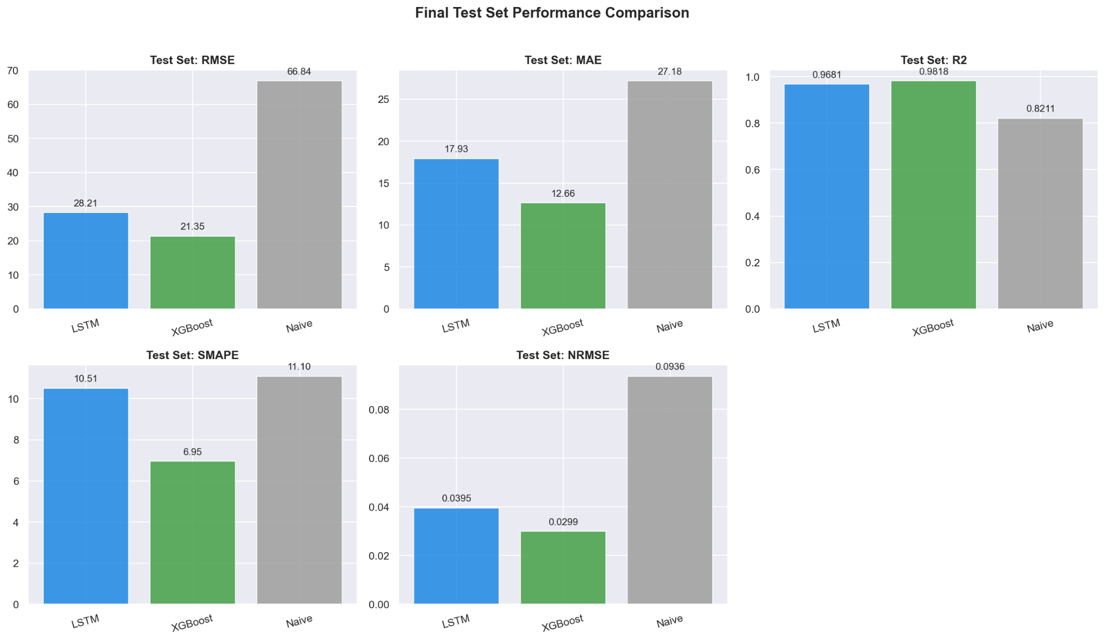

Overall Predictive performance
Table II summarizes all the evaluation metrics and shows that XGBoost outperformed the LSTM model across all five evaluation metrics. Both models still surpassed the naive persistence baseline, which proves that both approaches capture meaningful temporal patterns over simply using the last known value. A Diebold-Mariano test on the paired one-step-ahead test-set forecasts confirmed that the XGBoost advantage is statistically significant under both squared-error and absolute-error loss (DM = 10.49, p < 0.001; DM = 19.41, p < 0.001), ruling out sampling variation as the source of the gap.

Cross-Validation Robustness
A 3-fold time series split cross-validation is also done to determine the consistency of the two models as shown in Table III.
- Cross Validation
Model | RMSE (kW) | MAE (kW) | R² | SMAPE (%) | NRMSE
LSTM (mean±std) | 48.10 ± 30.83 | 32.47 ± 21.15 | 0.9002 ± 0.1260 | 14.51 ± 7.62 | 0.0614 ± 0.0420
XGBoost (mean±std) | 27.65 ± 6.78 | 16.31 ± 3.59 | 0.9754 ± 0.0112 | 7.50 ± 1.05 | 0.0346 ± 0.0079

Fig. 5 presents the cross-validation metrics across folds for both models.
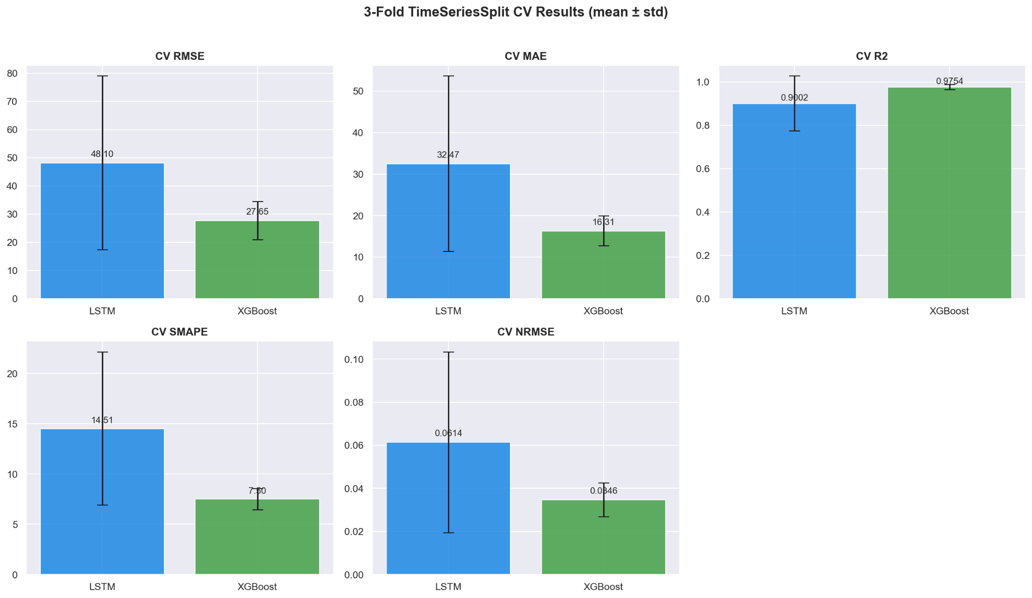
The XGBoost model shows that across all folds, it is stable and has a high accuracy, shown by the low standard deviations that reflect robust generalisation. On the other hand, the LSTM model shows a deviation across folds. During fold 1 when the train data was the smallest, LSTM produced a RMSE of 83.23 kW and an R2 of only 0.7548. These values indicate how sensitive LSTM models are to training data volume. As also shown in fold 2 and 3 where LSTM performance improved as the training set grew. This characteristic is a well-known limitation of deep learning models where historical data may be limited [1], [2].

Temporal Pattern Utilization
Engineered temporal features are demonstrated to help XGBoost by framing the forecasting problem as an explicit tabular relationship, where each lag and rolling statistic serves as an explicit feature for splitting. In contrast, the LSTM model learns the temporal dependencies implicitly via gradient-based optimization over a 96-timestep input window. This learning strategy difference may have contributed to the superior forecasting performance of XGBoost.
The input window (96 steps) for the LSTM was not tuned in the hyperparameter optimization process, and hence the obtained results reflect the selected experimental configuration rather than the optimal configuration of the LSTM. The same CU-BEMS 18-month time series from a single building in Bangkok with recurring daily and weekly operational patterns was used to train both models. This might have limited the potential advantage of LSTM in modeling long-range temporal dependencies, which may have contributed to the superior performance of XGBoost in the controlled experimental setting.
Additionally, previous studies reported strong LSTM performance compared with classical models such as GPR or SVR [1], [2]. This may be due to the unique methodology involved in those experiments, rather than the inherent superiority of the LSTM architecture. The findings are in line with previous studies [15], [16], [19] revealing that the quality of forecasts is influenced by dataset characteristics, the forecasting horizon, and the evaluation methodology. In this controlled experiment, where feature engineering is performed uniformly, the results indicate that feature engineering may contribute more to forecasting accuracy than model architecture alone.

Interpretability and Practical Considerations
The XGBoost model gives several practical advantages relevant to smart building deployment. Most notably, the final XGBoost model completed training in 1 min 43.8 s versus 45 min 16.5 s for LSTM on a CPU-only setup (Intel Core i7-3770K @ 3.50GHz, 16GB DDR3 RAM), roughly a 26-fold difference, alongside better reproducibility and lighter compute requirements. XGBoost also creates feature importance that can be used to identify which part of the building influences its load the most.
While the LSTM model is underperforming in this target, it may still be preferred in certain scenarios where the occupancy shifts rapidly so that it cannot be captured well enough through tabular feature engineering. The LSTM model has the capacity to retain information over long sequences and weight inputs dynamically that may outweigh the advantages of tabular gradient boosting in such cases.

Limitations
There are several limitations of this study that need to be acknowledged. First, only aggregate power consumption and basic environmental variables were used, not sub-load measurements and additional external weather information. This design has the advantage that using data generally utilized in building energy management systems makes the setup more practical. However, adding more data elements could provide a better understanding of model performance for more complex datasets, and this constraint may have disproportionately affected LSTM, since deep sequential models are often reported to benefit from richer multivariate input, though this study does not test that hypothesis directly. Second, the comparison was strictly between LSTM and XGBoost under the chosen configurations. Exploring alternative architectures, varying the sequence lengths, or applying different optimization methods could give different results. Finally, the study was performed on one academic building in Bangkok, and it is necessary to validate the results with other building types, climates, and operating conditions for wider generalizations.

Conclusion
This study presented a controlled comparison between a three-layer stacked LSTM network and an XGBoost model for short-term smart building energy consumption forecasting using the publicly available CU-BEMS dataset. Under identical preprocessing, feature engineering, and evaluation procedures, XGBoost consistently outperformed LSTM across all evaluation metrics on both the final test set and three-fold time-series cross-validation, with the advantage confirmed as statistically significant by the Diebold-Mariano test. Cross-validation further showed that LSTM exhibited higher performance variability when trained on limited data, while both models significantly outperformed the persistence baseline.
These findings demonstrate that, under a controlled experimental setting using explicit lag and rolling feature engineering, XGBoost can achieve superior forecasting accuracy while requiring substantially lower computational resources. The results also indicate that proper feature engineering and data preprocessing can have a greater influence on forecasting performance than model complexity alone.
Future research is encouraged to expand this benchmark by testing other forecasting models, adding more data sources like sub-load measurements, external weather data, and occupancy data, and testing the results in other building types and climatic regions to increase the generalizability of the conclusions.
Data Availability: Dataset is available from kaggle at https://www.kaggle.com/datasets/claytonmiller/cubems-smart-building-energy-and-iaq-data/code
Author Contributorship
Giovanni August Immanuel Wijaya was responsible for the research design, methodology, experimental execution, data analysis, and manuscript writing. Karel Nathanael Tanoe contributed to conceptualization, research design, data validation, manuscript writing, and manuscript review. Diana contributed to project supervision and methodology review. Shania Pricillia contributed to project supervision, academic advising, result validation, and project administration.

References
- M. Faiq et al., “Prediction of energy consumption in campus buildings using long short-term memory,” Alex. Eng. J., vol. 67, pp. 65–76, Mar. 2023, doi: 10.1016/j.aej.2022.12.015.
- X. Zhou, W. Lin, R. Kumar, P. Cui, and Z. Ma, “A data-driven strategy using long short term memory models and reinforcement learning to predict building electricity consumption,” Appl. Energy, vol. 306, p. 118078, Jan. 2022, doi: 10.1016/j.apenergy.2021.118078.
- M. S. U. Haq et al., “Explainable deep learning combined attention-based LSTM for building energy prediction: a framework from the perspective of supply side,” Energy Build., vol. 350, p. 116638, Jan. 2026, doi: 10.1016/j.enbuild.2025.116638.
- N. N. V. Nhat, D. N. Huu, and T. N. T. Hoai, “Evaluating the EEMD-LSTM model for short-term forecasting of industrial power load: A case study in Vietnam,” Int. J. Renew. Energy Dev., vol. 12, no. 5, pp. 881–890, Sep. 2023, doi: 10.14710/ijred.2023.55078.
- N. E. Assri, M. A. Jallal, S. Chabaa, and A. Zeroual, “Enhancing building energy consumption prediction using LSTM, Kalman filter, and continuous wavelet transform,” Sci. Afr., vol. 27, p. e02560, Mar. 2025, doi: 10.1016/j.sciaf.2025.e02560.
- Z. Du, “Prediction of Building Energy Consumption Based on LSTM-SVR-Random Forest Hybrid Model,” Appl. Comput. Eng., vol. 115, no. 1, pp. 75–85, Dec. 2024, doi: 10.54254/2755-2721/2025.18480.
- F. Zhou, C. Yang, and Z. Wang, “Prediction of building energy consumption for public structures utilizing BIM-DB and RF-LSTM,” Energy Rep., vol. 12, pp. 4631–4640, Dec. 2024, doi: 10.1016/j.egyr.2024.10.044.
- K. Li, J. Tian, W. Xue, and G. Tan, “Short-term electricity consumption prediction for buildings using data-driven swarm intelligence based ensemble model,” Energy Build., vol. 231, p. 110558, Jan. 2021, doi: 10.1016/j.enbuild.2020.110558.
- D. Kim, G. Seomun, Y. Lee, H. Cho, K. Chin, and M.-H. Kim, “Forecasting building energy demand and on-site power generation for residential buildings using long and short-term memory method with transfer learning,” Appl. Energy, vol. 368, p. 123500, Aug. 2024, doi: 10.1016/j.apenergy.2024.123500.
- A. Ahmed et al., “Novel deep neural network architecture fusion to simultaneously predict short-term and long-term energy consumption,” PLOS ONE, vol. 20, no. 1, p. e0315668, Jan. 2025, doi: 10.1371/journal.pone.0315668.
- N. Shahsavari-Pour, A. Heydari, F. Keynia, A. Fekih, and A. Shahsavari-Pour, “Building electrical consumption patterns forecasting based on a novel hybrid deep learning model,” Results Eng., vol. 26, p. 104522, Jun. 2025, doi: 10.1016/j.rineng.2025.104522.
- I. H. O. Ali, A. Agga, M. Ouassaid, M. Maaroufi, A. Elrashidi, and H. Kotb, “Predicting short-term energy usage in a smart home using hybrid deep learning models,” Front. Energy Res., vol. 12, Sep. 2024, doi: 10.3389/fenrg.2024.1323357.
- H. Wan, G. Huang, Y. Huang, and N. Ghadimi, “Energy consumption prediction in buildings using LSTM and SVR modified by developed Henry gas solubility optimization,” Sci. Rep., vol. 15, no. 1, p. 38037, Oct. 2025, doi: 10.1038/s41598-025-21835-4.
- O. A. Alawi, H. M. Kamar, and Z. M. Yaseen, “Optimizing building energy performance predictions: A comparative study of artificial intelligence models,” J. Build. Eng., vol. 88, p. 109247, Jul. 2024, doi: 10.1016/j.jobe.2024.109247.
- G. Airlangga, “Evaluation of Ensemble and Hybrid Models for Predicting Household Energy Consumption: A Comparative Study of Machine Learning Approaches,” Indones. J. Artif. Intell. Data Min., vol. 8, no. 1, p. 94, Dec. 2024, doi: 10.24014/ijaidm.v8i1.32819.
- M.-J. Park and H.-S. Yang, “Comparative Study of Time Series Analysis Algorithms Suitable for Short-Term Forecasting in Implementing Demand Response Based on AMI,” Sensors, vol. 24, no. 22, p. 7205, Nov. 2024, doi: 10.3390/s24227205.
- N. W. Azani, C. P. Trisya, L. M. Sari, H. Handayani, and M. R. M. Alhamid, “Performance Comparison of ARIMA, LSTM and SVM Models for Electric Energy Consumption Analysis,” Public Res. J. Eng. Data Technol. Comput. Sci., vol. 1, no. 2, Feb. 2024, doi: 10.57152/predatecs.v1i2.869.
- M. Neshat, M. Thilakaratne, M. El-Abd, S. Mirjalili, A. H. Gandomi, and J. Boland, “Smart buildings energy consumption forecasting using adaptive evolutionary bagging extra tree learning models,” Energy, vol. 333, p. 137130, Oct. 2025, doi: 10.1016/j.energy.2025.137130.
- M. Hasan et al., “A state-of-the-art comparative review of load forecasting methods: Characteristics, perspectives, and applications,” Energy Convers. Manag. X, vol. 26, p. 100922, Apr. 2025, doi: 10.1016/j.ecmx.2025.100922.
- K. Sundaram, K. R. S. Preethaa, Y. Natarajan, A. Muthuramalingam, and A. A. Y. Ali, “Advancing building energy efficiency: A deep learning approach to early-stage prediction of residential electric consumption,” Energy Rep., vol. 12, pp. 1281–1292, Dec. 2024, doi: 10.1016/j.egyr.2024.07.034.
- M. Pipattanasomporn et al., “CU-BEMS, smart building electricity consumption and indoor environmental sensor datasets,” Sci. Data, vol. 7, no. 1, 2020, doi: 10.1038/s41597-020-00582-3.

